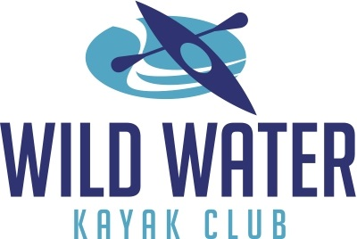

MEMBER DECLARATION FORM

To ensure the safety, health and welfare of all persons paddling with Wild Water Kayak Club (WWKC), all persons must complete this declaration form prior to returning to paddling with the club. The form must be completed a maximum of 3 days before returning to paddling and every 14 days thereafter.

Declaration
I declare that-

[1] I have read and understood the WWKC Covid-19 Protocol. I am responsible for keeping informed of, and adhering to, public health guidelines and club protocols.

[2] I do not have any signs of symptoms of a cough, fever or chills, high temperature, sore throat, breathlessness, tiredness or flu like symptoms now or within the past 14 days.

[3] I have not been diagnosed with confirmed or suspected Covid-19 in the last 14 days.

[4] I have not been in close contact of a person who is a confirmed or suspected case of Covid-19 in the past 14 days (i.e. less than 2 metres for more than 15 minutes accumulative in one day).

[5] I have not travelled or returned from a foreign country within the past 14 days.

[6] I have not been advised by a medical professional to self-isolate or cocoon at this time.

[7] I do not have any underlying health issues that may require further protection against contracting Covid-19.

[8] If any of the above changes prior to, or during, a club activity I will immediately inform the group leader/co-ordinator and discontinue my participation in the club activity. I will not participate in any paddling for 14 days from the end of my symptoms.

Contact Details
My contact details are:

Name
Address
Telephone No.

SIGNED:

DATED:

*Data Collection - Please note that by completing and submitting this form, you are consenting to the collection of this data for the purpose of the club's management of safety in the context of Covid-19.

